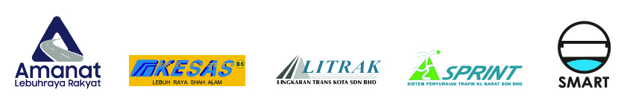

WHISTLEBLOWING REPORTING FORM
Name: |  | NRIC No.:
Phone No: |  | Email Address:
Employee No: |  | Department:
Details of Allegation

Person(s) Involved:

Location:

Date and Time:

Incident/Details of Allegation:

How Incident Was Detected:

Evidence Available:

Concern and/or Potential Impact of Allegation:

Declaration:
______________________________________________________________________________

I hereby declare that the information provided herein is true to the best of my knowledge and
belief and I have made this disclosure voluntarily. I understand that Amanat Lebuhraya Raya Berhad (ALR) Group will use the information provided for the investigation process.

…………………………………………..
Name:
Date:

